TCSS 590A

Embedded Real-Time System Programming

Midterm - Spring 2006

Name _______________________________________________

1) CLEARLY show on a timing diagram the parameters for a real time periodic task:
- Compute time C_{i}
- Finish time f _{i}
- Arrival time a _{i}
- Phase Φ _{i}
- Start time s _{i}

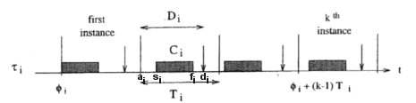

And define:

- Response time:

R _{i} = f _{i} - a _{i}

- Lateness:

L _{i} = f _{i} - d _{i}

- Laxity:

R _{i} = d _{i} - a _{i} - C _{i}

- Name five properties that real-time systems must have to support critical applications:

1. Timeliness – must meet deadlines appropriately

2. Design for peak-load – Can’t crash under peak loads

3. Predictability – Must not have unanticipated surprises

4. Fault Tolerance – The system must be robust and fail-safe

5. Maintainability – Must be modifiable as requirements evolve

- Specify the scheduling algorithm that you would use in each of the aperiodic tasks, EDD, EDF, LDF, TreeSearch, Spring: Which yield optimal scheduling?

- Apply EDF to schedule the following set of tasks J_{i} with precedence constraints:

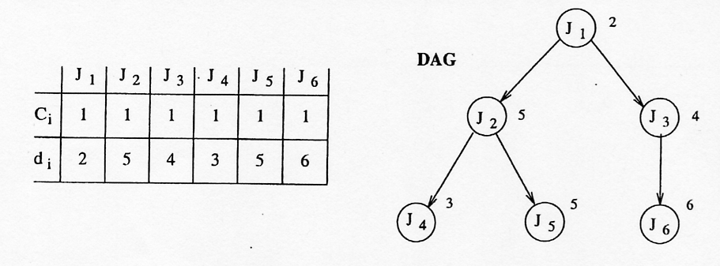

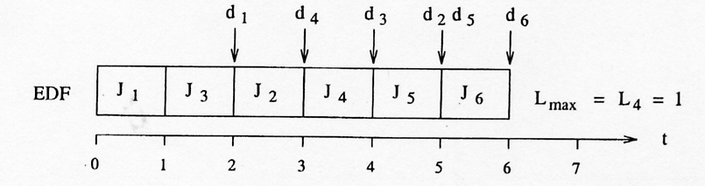

Apply LDF to schedule the set of tasks:

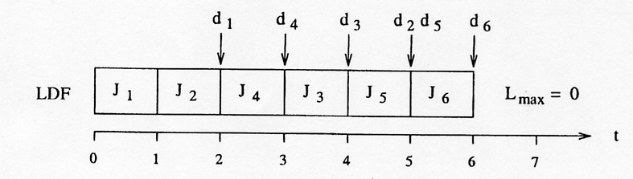
5) Verify the schedulability according to the Rate Monotonic algorithm for the following set of periodic tasks.
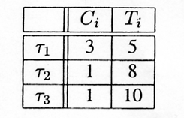
Construct the schedule using RM.
(This should go to 40 units→)
6) You did two projects using the NetBurner A/D converter. In the first you used Port A as a 4 bit output port. What did you need to do to program it?

Initialize: The default on the Configuration and Control registers are for digital I/O on Port A,
so nothing was required. The Port A Data Direction Register bits needed to be
programmed for output.
Output: The output follows writes to the buffered Data Register in the A/D.

On the second project you used both Port A and Port B as A/D input Ports. What did you need to do to program it in that mode?

Initialize: The Configuration Register needs to be set to “stop”, Port A & B Control Registers set,
Port A & B Data Direction Registers set, Port A & B QADC timing registers set, and
the Configuration Register set to “start”. The Queue must be programmed for the
sampling sequence, and finally, the scan initiated.
Input: The input is obtained by reading from the queue.
7) On the third project, what did your thermistor characteristic look like (resistance vs temperature) and what should the voltage vs temperature curve look like in the following circuit?

What is a reasonable sampling rate for this circuit and why?

It takes 20 sec for the thermistor to reach 63% of its change from initial to final temperature
characteristic. It is most likely overkill to sample it more often than once every half minute.

What would be the criteria for “scheduling” the sampling?
Most likely it should be treated as a task that has a very low priority. Its time constant is likely
much longer than the periods of other tasks in the system. Its deadline should likely be
considered as very soft.

